**SOP 19 Associated Document 2**

**Progress report guidance for JRMO reviews**

1. **Annual Sponsor Oversight Questionnaire (SOQ)**

Reviewed as per EDGE workflow.

Please refer to **Appendix 1** for Sponsor oversight process flowchart.

For Senior Research Management & Governance Officer (SRM&GO) or delegate:

1. If in section 1 all answers selected 'correct' and all answers in section 3 marked as 'no' then upload to EDGE and indemnity.
2. If in section 1, any fields (apart from start date) marked as 'updated' and/ or in section 3, any fields marked 'yes' to be sent to the relevant SRM&GO for review and approval.
3. **Confidentiality Advisory Group (CAG) Annual reports**

Please refer to **Appendix 2** for the CAG PR Process flowchart.

The study will be allocated to the SRM&GO who reviewed the original section 251 application for this study. If original SRM&GO is no longer in the post, these should be sent to the current SRM&GO for that theme. Allocated person to perform review as above and additionally:

1. Ensure any conditions set out in the initial approval letter have been met.
2. **Development Safety Update Reports (DSUR)**

The allocated person will review submitted documents to include (but is not limited to):

1. Ensure the DSUR and cover letter present and using [SOP 19 AD 4 and AD 5](http://www.jrmo.org.uk/performing-research/standard-operating-procedures-sops/sop-19/) , and that no template text remains
2. Read the whole report, actions specific sections as below.
   1. Check section 3 against EDGE or/ and REDA (NB safety actions reasons only, not all amendments should be listed)
   2. Check the Reference Safety Information listed matches EDGE.
   3. Check recruitment numbers are as expected.
   4. Review EDGE for other studies with same SOP sponsored by the same organization (NB Barts Health and Queen Mary are not the same organization)
   5. Section 7b-d – it is not necessary to perform a reconciliation between the JRMO Pharmacovigilance system and report as this is performed regularly by monitors. However, Check EDGE to ensure reconciliation has been performed.
   6. Section 8b- review issues flagged to ensure the GCP team aware, and these have been logged as appropriate.
   7. Section 18, 19 & 20 review with care and assess if risk category or assessment need to be updated. Escalate as needed.
   8. Complete EDGE workflow

**Filing**

1. Ensure a signed copy of the Progress Reports (PR) is saved in EDGE and Indemnity Folder

Appendix 1: Sponsor Oversight Process Flowchart

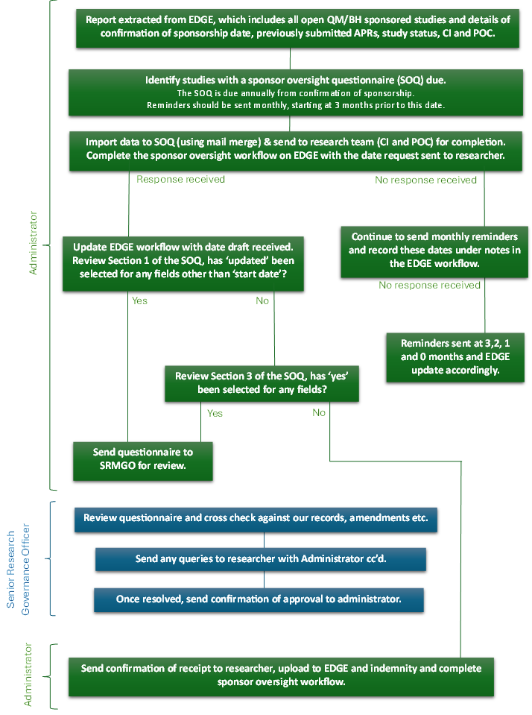

Appendix 2: CAG PR Process Flowchart

